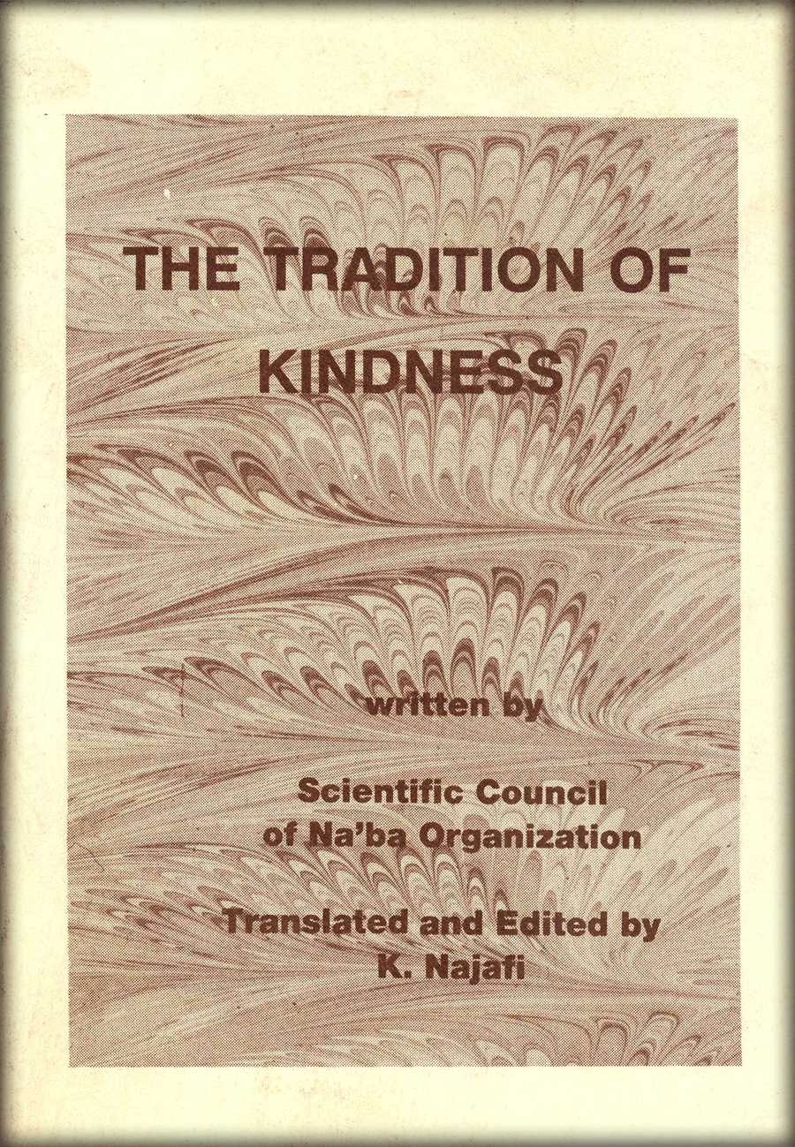

THE TRADITION OF KINDNESS

By: Scientific Council of Naba Organization

Translator & Editor: K. Najafi

In the Name of Allah

My name is ‘Jaber bin Abdollah Ansari’. I am one of the followers of Prophet Mohammed ibn Abdullah (S.A.W.). I’ve had a very long life; leven saw Imam Baqer (A.S.). By the wishes of the prophet himself, I gave his regards to the Imam.
I became acquainted with this great family from the early days of Islam, and have both sweet and bitter memories of them and happenings concerning them.
...This time I would like to recall one of the sweetest memories, one of the greatest events, something that I can never forget.
Every once and a while I would visit the Holy Prophet’s (S.A.W.) daughter. During these visits I would learn something new, and be told about some of the secrets of this great family. This time when I made a visit to Hazrat-e- Zahra’s (A.S.) house, she seemed to be very happy. Some special event had happened, I asked her why she was so happy, and this great lady narrated the following story.
That day my father (the prophet) visited me. I saw him every day but still could not see him enough. I loved him dearly. He was more loved than my own soul. His kind and open face inspirited me with new life. It is quite obvious what he meant for me, for this was the same man who brought grace and blessing to the world. He would call me the fruit of his life-he was epitome of affection and kindness.
Every time he embraced me, he would shower me with kisses and say:
“My daughter! From you comes the odor of heaven.”
He would even place my hands between his own and start kissing them, filling me with shame.
He would tell me: “Dear Zahra, you are like a mother to me! Whoever torments you torments me. You are of the enlightened ones, and a piece of my own flesh. Zahra! You are dear and deeply loved by your father. Your anger is the cause of God’s anger, and your happiness is the cause of God’s happiness.”
That day as was his custom he came to visit me, but he seemed tired and low-spirited. He wasn’t happy and energetic as he always was. My father spoke to me: “My dear daughter, I feel tired and weak, and would like to rest a little.”
I became depressed and worried, and said: “Dear father, don’t say you are tired. God forbid that I should see you tormented and tired.”
My father replied: “Dear Zahra bring me that woolen Yemeni cloak and throw it over me.”
I immediately brought the ‘woolen cloak’ and covered him with it.
Sad and worried, I observed his angelic and beautiful face, shining like the full moon. I rejoiced seeing him, his very being warming me and giving me hope, I must remind you, that it was during these very hard and eventful years that his prophet hood was tested most, as he tried to lead the people. I remembered well most events that occurred during his life and I kept recalling them, memorizing each one.
I remembered well when my son, “Hasan’s” sweet voice would call out; ‘Hello, mother’. He was the Prophet’s eldest grand son.
‘Hassan’ looked very much like the Holy Prophet (S.A.W.), and my father loved him very much. He loved him more than a grandfather could love his grandson.
He would place him on his shoulders, saying; “Anyone who loves me, should love Hassan as well.”
My father would quite firmly give order that his followers and friends should be Hassan’s followers and friends as well.
One time the Prophet’s followers were witness to the fact that during prayers, the prophet made an exceptionally long ‘sujdeh’. After prayers they asked him: “Dear Prophet of God, why did you make such a long ‘sujdeh’? Did an angel appear?”
The prophet replied: No, as I was making my ‘sujdeh’ my son Hassan got on my back, I waited until he got off before I arose.
One day when Hassan had come home, he told me: “Mother I smell a nice odour. Now, this odour was the odour of my grandfather, the Prophet of God.”
I told him: “yes, my dear son, this nice odour is the odour of the Prophet himself.”
Hassan then inquiringly asked: “Mother, where is he?!” I replied: “My father is resting under that woolen cloak.”
Hassan quickly went towards the cloak. He gave his greetings to the Holy Prophet (S.A.W.) and said: “Grandfather Will you allow me to come near you?”
My father who heard his voice said:
“Greetings to you my son! You yourself are the owner of all permission. Come; come closer to me, for I am anxious to see you.”
The Prophet warmly embraced Hassan and held him close to himself till he fell asleep.
It wasn’t soon until Hossein entered the house. “Mother, greetings!”
“Greetings to you my son, the light of my eyes and fruit of my heart, welcome.”
I honestly don’t know which one my father preferred most, for he showed the same love and deviation to both. Maybe he loved them both the same.
One thing for sure was that he loved them both tremendously, maybe even too much. The reason for this great love was quite obvious. My father himself used to say: “God has ordered me to love and cherish these two, for God supports those friends who are friends of theirs.”
Most or probably all of the prophets’ companions and followers heard him repeat over and over again that: “Hassan and Hossein are leaders, leading both the people in this world, as well as those (youths) in the world (heaven).” He emphasized the fact that both of them were innocent, and their enemies would be despised and cursed by God.
Most of the time the Holy Prophet (S.A.W.) would speak about both of them equally. But on some occasions he would speak either of Hassan (A.S.) or Hossein (A.S.).
For example one time he spoke either of Hassan as such: “The blood of the Muslims will be saved by him, through the grace of God.” About Hossein he would say: “Hossein is of me as I am of him.” My father would say that the protectors of God’s religion belonged to him, and often stated that the Imams and his successors would descend from Hossein.
Of course he said other things about Hossein that was kept a secret from me. And only at times would hint to me what great tragedy would happen in Hossein’s life.
Anyway, when Hossein entered the door he knew that his grandfather was there. He said: “Mother I smell something very nice and sweet, it seems like the smell of my grandfather, the Prophet of God.” And I answered: yes, your grandfather and brother are both here, resting under the woolen cloak.”
Hossein approached them and said: “Grandfather, greetings, O’ messenger of God, greetings! Do I have your permission to come to you?”
My father replied: “Greetings, greetings to you my son, greetings to the light of my descendants. Come, come to me. Hossein then too went to his grandfather.”
It was at this moment that my husband arrived. As he entered the door he cried out: “Greetings! Oh, daughter of God’s messenger” His voice filled me with strength what can I say of him? No matter how much I try to explain, I can never explain well enough of the special bond between father and Ali. Everyone knows the prop loved no one more than he loved Ali, even me. Is it surprising? Yes, he did not even love me as much as he loved Ali. Even though my fathers caring and kindness me had no boundaries, in another way h to explain he loved Ali more.
It is obvious to his devotion towards for since he was a child he embraced cared for Ali as his own son. During all years he made pilgrimage to the Hara Cave, and before being appointed the messenger of God, Ali was his witness and sole confident as to my father’s mission. The first I son to have faith in him was Ali. He was only a boy of thirteen when my father showed announced him as his successor to the tribe of Quraish. His strength in his own faith was through him. He knew him as his own, and trusted Ali to protect and spread his faith. Over and over again my father declared that, after him was Ali.
No one was more aware of the secrets and science held in the Holy Qur’an but Ali. He knew the Qur’an verse by verse. My father knew Ali as the knowledge of the book.
Ali loved the prophet very much; he cherished him more than his own life. That is why when the Holy Prophet (S.A.W.) wanted to escape from the trap of the non-believers. Ali placed himself in the prophet’s place, knowing that the sword-bearers meant to kill the prophet. Over and over again Ali risked his life for the prophet. Of course, he would say that in the heat of the battle when things looked bleak the prophet had saved them from the claws of the enemies.
Anyway this was the Ali who now entered our house. I returned his warm greetings. He too knew that the prophet was in our house; Ali knew his perfumed smell better than anyone else. He turned to me and asked: “Is this my brother and cousin that I smell?” And I replied: Yes, my dear husband, he long with our two children are lying over there under the woolen clock. Ali approached them and said: “Oh, prophet of God! Greetings! Will you give me permission to approach you so that I too may loin you?” The Holy Prophet (S.A.W.) replied: “Greeting to you my dear brother and successor, yes come closer.” Ali then approached the prophet.
Seeing them, my father, my husband and my children all together, put a certain yearning in my heart so as to also be a part of that special group. Everyone was waiting for me, the prophet, Ali, my children, the angels, Gabriel and God. I too approached my father and asked: “Oh, Prophet of God, will you too give me permission to sit with you?”
The prophet said: “Greetings my daughter, my soul, yes, comes. I went and sat among my loved ones, here, was the very center of kindness. Kindness and loved radiated from those around me.”
An event was about to take place, some thing in which my father knew before anyone else. He took both sides of the cloak in h hands, surrounding us five. Then lifting his right hand towards the sky he started whispering,
“Dear God, these are my family.”
Their flesh and bloods are of mine.
Anyone who hurts or bothers them hurts and bothers me. And anyone who pleases them pleases me.
Dear Creator, I am an enemy to those who are enemies of them. And I am a friend to those who are friends of theirs. They are of me, and I am of them.
We are one. We were created from one light.
All of this was said by the prophet; however he had also said this before. But this time it was different, as if something else was about to happen. Following the prophet’s words came this prayer.
“So dear God, bless us with your blessings and keep us away from the unpure. Make them of the pure and holy ones.”
The prophet prayed from the depth of his heart, and we too said ‘amen’ from the depth of our hearts.
The Almighty God heard the prophets’ words and decreed to all heavenly beings and angels.
“Oh, heavenly beings!”
“Do you see them; these five beings are gathered under this cloak? Be aware was I who created the open skies, the earth, the shining moon the radiating the spinning heavenly bodies, and the moiled seas. I did not create those but out of my kindness and friendship tow them.”
Gabriel then asked: “Oh, Almighty and who are those gathered together under that cloak that you speak so highly of?”
“They are the Holy Prophets (S.A.W.) Ho hold, and the source of the prophetic mission. These five people are Fatimah (A.S.), father, her husband, and her two children.”
I at once became ashamed of God’s k ness, and grace towards my family and me.
Gabriel then asked: “Dear God will give me permission so that I may also them and become the sixth?”
And God answered; “Yes, I give you I mission so that you may approach them give the prophet a message from me.”
Gabriel descended from the heaven and told the Holy Prophet (S.A.W.):
“Oh, Prophet of God! The Almighty asks me to tell you about yourself and your family.”
“I swear that I did not open the skies,
Nor the wide earth,
Nor the shining moon,
Nor the radiating sun,
Nor the shining heavenly bodies,
Nor the turmoiled seas,
…But for you and my kindness towards you.”
“Oh, Prophet of God! It is only God who has given me permission to visit you.”
“Dear God! This is Gabriel your trusted angel, who has brought my father a message from you, the Almighty. How can we ever pay back this special attention and kindness that you have given us?”
So, therefore Gabriel approached us and became the sixth person. He said to my father:
“Allah only desires to keep away the uncleanness from you, O people of the House! And to purify you a (through) purifying.” (33-23)
All of us were happy. Ali asked from my father: “Oh, Prophet of God. What is the reason for all of us to be gathered tog here under this cloak? What event is to follow?”
The Holy Prophet (S.A.W.) replied: “I swear to God who has chosen me to be truthful, honest and to guide the lost souls. If any among human beings, among my Followers recall and contemplate such event, the blessings and Grace of God will surely f and be bestowed upon them.”
Ali then happily replied: “I swear to that we and our followers are of the true.”
Fatimah’s speech, which had reached point, left me speechless.
Oh’ God! In this small, poor house and under this coarse woolen cloak, what magnificent event has taken place? Oh, God! How close and dear are these people to you God! Have you created everything because of them?
Why shouldn’t they be dear? They closed their eyes to all the beauties of this world for you. Even though you gave this world to them.
This great event took place in Zahra’s (A.S.) house and no one except the angels and heavenly beings witnessed it.
It also happened two more times, once at Umm-e-Salamas house (one of the prophet’s wives) and once at Aishah’s.
As a result, this great event is so famous and well known that most people know about it. It is also well known that the Holy Prophet (SAW) continuously went every day for eight months to Fatimah’s house, and repeated this verse loudly so that people may hear:
“Allah only desires to keep away the uncleanness from you, O people of the House! And to purify you a (thorough) purifying.” (33-32)
“Greetings and salutations to the Household of the Prophet.”
So that, everyone would be aware as to who was considered the Holy Prophet’s -(S.A.W.) Household. It was only after this event that theses five people, Fatimah (A.S.), her father, her husband and her two children (Hassan and Hossein) were know as-“companions of the cloak”.

THE END

